# Quantifying intra-urban socio-economic and environmental vulnerability to extreme heat events in Johannesburg, South Africa

* + - 1. Craig Parker¹*, Craig Mahlasi², Tamara Govindasamy², Lebohang Radebe¹, Nicholas Brian Brink¹, Christopher Jack³, Madina Doumbia⁴, Etienne Kouakou⁵, Matthew Chersich1, Gueladio Cisse⁴, Sibusisiwe Makhanya², for the HE2AT Center Group

## Affiliations

Wits Planetary Health Research, Faculty of Health Sciences, University of the Witwatersrand, Johannesburg, South Africa

IBM Research - Africa, South Africa

Climate System Analysis Group, University of Cape Town, South Africa

University Peleforo Gon Coulibaly, Côte d'Ivoire

Centre Suisse de Recherches Scientifiques, Côte d'Ivoire

* + - 1. The HE2AT Center Group consists of: Aakin Bobola, Abdoulaye Tall, Achiri Ndikum, Adaji Aishatu, Adja Ferdinand Vanga, Admire Chikandiwa, Akbar Waljee, Amy Beukes, Andrew Meme, Anna Steynor, Bonnie Joubert, Brama Kone, Bruce Hewitson, Cathy Mwangi, Cherlynn Dumbura, Christopher Jack, Chuansi Gao, Craig Mahlasi, Craig Parker, Darshnika Lakhoo, Donrich Willem Thaldar, Duncan Mitchell, Dusty-Lee Donnelly, Elizabeth Frederick, Etienne Vos, Gciniwe Dlamini Baloyi, Gillian Marmelstein, Gueladio Cissé, Hendrik Hamann, Iba Dieudonné Dely, Ijeoma Solarin, Ilias Maliha, Jasper Maguma, Jetina Tsvaki, Ji Zhu, Khady Sall, Kimberly McAlpine, Komminist Weldemariam, Kwesi Quagraine, Lebohang Radebe, Leon Mbano, Lisa, Lois Harden, Lukman Abdulrauf, Madina Doumbia, Margaret Brennan, Matthew Chersich, Kimberly McAllister, Nicholas Brian Brink, Nontokozo Langa, Okoue Emerence, Olumuyiwa Adegun, Paul Ogendi, Peter Marsh, Peter Munyi, Pierre Kloppers, Piotr Wolski, Reneilwe Satekge, Rodger Duffett, Rutendo Sibanda, Ruvimbo Forget, Sabina Omar, Sibusisiwe Audrey Makhanya, Stanley Luchters, and Tatenda Makanga.

## Corresponding Author

* + - 1. Craig Parker
      2. Email: craig.parker@witsphr.org
      3. Wits Planetary Health Research
      4. Faculty of Health Sciences
      5. University of the Witwatersrand
      6. 7 York Road, Parktown
      7. Johannesburg, 2193
      8. South Africa

## Abstract

* + - 1. Urban populations face increasing vulnerability to extreme heat events, particularly in rapidly urbanising Global South cities where environmental exposure intersects with socioeconomic inequality and limited healthcare access. This study quantifies heat vulnerability across Johannesburg, South Africa, by integrating high-resolution environmental data with socio-economic and health metrics across 135 urban wards. We examine how historical urban development patterns influence contemporary vulnerability distributions using principal component analysis and spatial statistics.
      2. Environmental indicators (Land Surface Temperature(LST), vegetation indices, and thermal field variance) were combined with socioeconomic variables (including crowded dwellings and healthcare access) and health metrics (prevalence of chronic diseases) in a comprehensive vulnerability assessment. Principal component analysis revealed three primary dimensions explaining 56.6% (95% CI: 52.4-60.8%) of the total variance: urban heat exposure (31.5%), health status (12.8%), and socio-economic conditions (12.3%). Built-up areas showed weak but significant correlations with heat indices (ρ = 0.28, p < 0.01), while higher poverty levels demonstrated moderate positive correlations with LST (ρ = 0.41, p < 0.001).
      3. The spatial analysis identified significant clustering of vulnerability (Global Moran's I = 0.42, p < 0.001), with distinct high-vulnerability clusters in historically disadvantaged areas. Alexandra Township showed the highest combined risk (LST: 29.8°C ± 0.4°C, NDVI: 0.08 ± 0.02), with 89.2% of residents dependent on public healthcare facilities. Northern suburbs formed a significant low-vulnerability cluster (Mean HVI = 0.23 ± 0.07, p < 0.001), benefiting from greater vegetation coverage and better healthcare access.
      4. These findings demonstrate how historical planning decisions continue to shape contemporary environmental health risks, with vulnerability concentrated in areas of limited healthcare access and high extreme heat exposure. Results suggest the need for targeted interventions that address both environmental and social dimensions of heat vulnerability, particularly focusing on expanding healthcare access in identified hotspots and implementing community-scale green infrastructure in high-risk areas. This study provides an evidence-based framework for prioritising heat-resilience initiatives in rapidly urbanising Global South cities while highlighting the importance of addressing historical inequities in urban adaptation planning.

*Keywords*

*Urban Heat Vulnerability, Spatial Analysis, Healthcare Access, Environmental Justice, Climate Adaptation, Principal Component Analysis, Johannesburg, Environmental Health*

## Statements and Declarations

### Acknowledgement

* + - 1. This research was conducted as part of the HE2AT and Health in Africa Transdisciplinary (HEAT) Center initiative, supported by the NIH Common Fund under Award Number U54 TW 012083. We acknowledge the valuable contributions of the HE2AT Center Group, which includes researchers, collaborators, and supporting staff from partner institutions .... Their collective efforts in data sharing, technical support, and capacity building have significantly advanced this research.
      2. We also extend our gratitude to the data owners and contributors who shared their datasets, enabling this study to integrate environmental, socioeconomic, and health metrics. Special thanks go to the Gauteng City-Region Observatory (GCRO) for providing the Quality of Life Survey data and to the United States Geological Survey for Landsat 8 satellite imagery.
      3. Finally, we are grateful for the administrative and technical support provided by the HE2AT Center Steering Committee and partner institutions and the guidance and input from the Publications Group. This publication reflects the authors' views and not necessarily those of the NIH or other supporting organisations.

### Ethics Approval

* + - 1. This research was conducted with approval from the Wits Human Research Ethics Committee in Johannesburg (reference number 200606). The study utilised secondary data analysis of publicly available datasets and followed the United States Department of Health and Human Services regulations for protecting human research subjects (45 CFR 46). All data were anonymised and processed in accordance with ethical research principles.

### Consent to Participate

* + - 1. Not applicable - this study used secondary data analysis of publicly available datasets and did not involve direct human participants.

### Consent to Publish

* + - 1. Not applicable - this manuscript does not contain any individual person's data in any form.

### Data Availability

* + - 1. The datasets analysed during the current study are available from the following sources:
      2. - Environmental metrics were derived from ERA5 reanalysis data and Landsat 8 satellite imagery (December-February 2020-2021), available from the United States Geological Survey [Earth Explorer](https://earthexplorer.usgs.gov/)
      3. - Socio-economic and health data were obtained from the Gauteng City-Region Observatory (GCRO) Quality of Life Survey 2020-2021, publicly available at [Gcro](https://www.gcro.ac.za/research/project/detail/quality-life-survey-vi-202021/)
      4. - Analysis scripts and processed data are available from the corresponding author upon request

### Author Contributions

* + - 1. **Conceptualisation:** Craig Parker, Craig Mahlasi, Tamara Govindasamy, Matthew Chersich and Sibusisiwe Makhanya conceived and designed the study.
      3. **Data acquisition, analysis, and interpretation:** Craig Parker, Craig Mahlasi, Tamara Govindasamy, Lebohang Radebe, Nicholas Brian Brink, and Sibusisiwe Makhanya conducted data collection, processing, and analysis.
      5. **Writing and revision:** Craig Parker wrote the original draft. Nicholas Brian Brink, Lebohang Radebe, Matthew Chersich, Gueladio Cisse, and Etienne Kouakou provided critical reviews and revisions of the manuscript.
      7. **Final approval:** All authors reviewed and approved the final manuscript.

### Competing Interests

* + - 1. **Financial interests:** Authors affiliated with Wits Planetary Health Research (Craig Parker, Lebohang Radebe, Nicholas Brian Brink, Matthew Chersich) hold indirect investments in the fossil fuel industry through their institutional pension funds. Additionally, their institution, the University of the Witwatersrand, invests in the fossil fuel industry through endowments and other financial reserves.
      3. **Non-financial interests**: The authors declare they have no non-financial competing interests.

1. **.**

## Introduction

* + - 1. Climate change is significantly reshaping urban life, with extreme heat events becoming more frequent and severe [1, 2]. Urban populations face increasing vulnerability to these events, with risks shaped by complex interactions between environmental exposure, socioeconomic conditions, and health status [3, 4]. This vulnerability is particularly acute in rapidly urbanising Global South cities, where historical inequalities and limited adaptive capacity compound environmental challenges[5, 6].
      2. Johannesburg, South Africa's largest city with 6.1 million inhabitants, presents a compelling case study of urban heat vulnerability[7]. The city's rapid urbanisation, pronounced socio-economic inequalities, and historical legacy of apartheid urban planning create distinct patterns of environmental risk[8, 9]. These factors interact with the urban heat island effect to produce heterogeneous vulnerability landscapes, particularly affecting disadvantaged populations [10]. Understanding these patterns is crucial for developing effective adaptation strategies, yet comprehensive analyses of urban heat vulnerability in African cities remain limited[2].

## Conceptual Framework and Current Knowledge

* + - 1. Urban heat vulnerability encompasses three interconnected dimensions: exposure, sensitivity, and adaptive capacity [1]. Exposure refers to the degree and duration of heat stress, typically quantified through environmental metrics such as Land Surface Temperature (LST) and Urban Thermal Field Variance Index (UTFVI). These indices, derived from satellite imagery and ground measurements, provide high-resolution data on urban heat distribution [11]. Notably, dense urban areas with limited vegetation show significantly higher surface temperatures, with differences of up to 5°C compared to well-vegetated neighbourhoods[12-16]
      2. Sensitivity reflects population susceptibility to heat stress, influenced by socio-economic conditions and health status. Recent studies demonstrate that chronic conditions such as cardiovascular disease, diabetes, and respiratory ailments significantly increase heat-related health risks[17-19]. These health vulnerabilities intersect with socio-economic disparities in Johannesburg, creating compound risk factors in disadvantaged communities [7, 20].
      3. Adaptive capacity, coping with and recovering from heat stress, depends heavily on access to healthcare, cooling infrastructure, and social support systems [21]. Limited healthcare access particularly affects heat vulnerability, as demonstrated by increased heat-related mortality in areas with restricted medical services [22]. In Johannesburg, historical planning decisions continue to influence the distribution of these adaptive resources, creating persistent spatial patterns of vulnerability [23].

## Research Gaps and Study Objectives

* + - 1. While existing research has examined individual components of heat vulnerability, three critical gaps remain:
  1. Limited integration of environmental, socio-economic, and health data in vulnerability assessments, particularly in Global South contexts
  2. Insufficient understanding of how historical urban development patterns influence contemporary heat vulnerability
  3. Lack of high-resolution spatial analyses that can inform targeted intervention strategies
     + 1. This study addresses these gaps through three specific objectives:
  4. Quantify the spatial distribution of heat vulnerability across Johannesburg by integrating high-resolution environmental data with socio-economic and health metrics
  5. Analyze the relationship between historical urban development patterns and contemporary heat vulnerability
  6. Identify priority areas for intervention based on compound vulnerability factors

## Data and Methods

* + - 1. We integrated environmental, socio-economic, and health data to assess heat vulnerability across Johannesburg's 135 wards. Environmental metrics were derived from ERA5 reanalysis data and Landsat 8 satellite imagery (December-February 2020-2021), selected for minimal cloud cover (<10%)[24]. Land Surface Temperature (LST) was calculated using thermal infrared bands with split-window algorithm atmospheric correction, while vegetation cover was quantified using the Normalized Difference Vegetation Index (NDVI). The Urban Thermal Field Variance Index (UTFVI) provided relative heat intensity measures, and the Normalized Difference Built-up Index (NDBI) quantified urban density. All environmental indices were processed in Google Earth Engine and aggregated to ward level using area-weighted averaging[25].
      2. Socio-economic and health data were obtained from the Gauteng City-Region Observatory (GCRO) Quality of Life Survey 2020-2021[26, 27]. Housing conditions were assessed through multiple indicators: crowding, defined as more than two persons per habitable room (excluding bathrooms and kitchens); infrastructure access, specifically focusing on the availability of piped water connections; and building materials, categorised as either formal (e.g., brick and cement) or informal (e.g., corrugated iron and wood). Economic vulnerability was measured using a composite food security index alongside participation in school feeding programs.
      3. Healthcare accessibility was evaluated using three specific measures derived from the GCRO survey: (1) Distance to Healthcare Facilities, defined as the proximity of residents to healthcare services, specifically examining the proportion of households within 1 km of a healthcare facility; (2) Public Healthcare Utilization Rates: the percentage of residents reliant on public healthcare facilities, highlighting dependency and accessibility for uninsured populations; and (3) Medical Insurance Coverage: the extent to which residents are covered by private medical insurance, reflecting their financial accessibility to healthcare services. These measures provide a detailed understanding of geographical and financial barriers to healthcare access in Johannesburg.
      4. Health indicators were also derived from the GCRO survey, which captured household-level health experiences[26, 27]The survey included the proportion of households reporting chronic conditions, such as diabetes and hypertension, and recent experiences with infectious diseases, including HIV, tuberculosis, and COVID-19. This self-reported household health data was then aggregated at the ward level, providing insights into the distribution of health vulnerabilities across the city.

### Analytical Methods

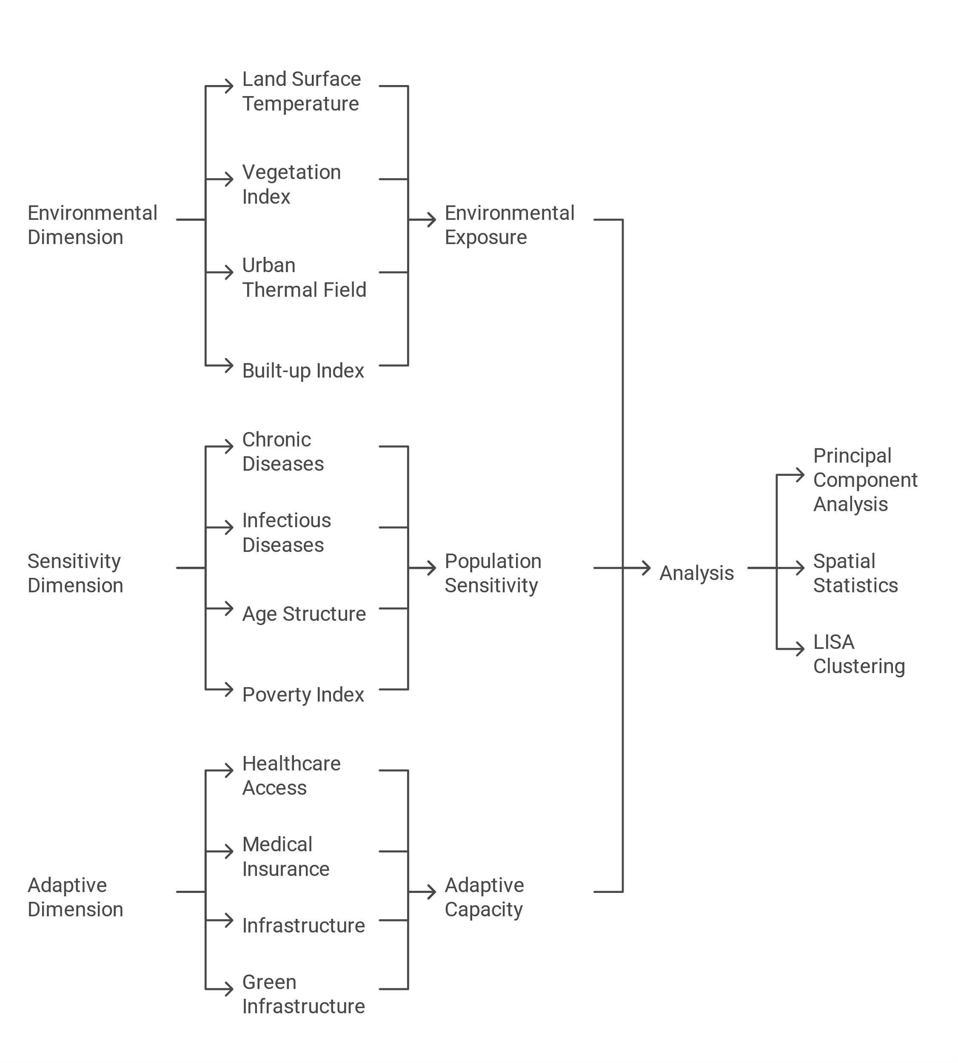

Figure 1: Analytical Framework for Assessing Urban Heat Vulnerability in Johannesburg: Integration of Environmental, Social, and Healthcare Dimensions. Schematic showing the methodological approach and data integration process.

* + - 1. We employed a three-stage analytical approach to assess heat vulnerability patterns across Johannesburg(Figure 1). First, all variables underwent z-score normalisation to ensure comparability; an initial assessment of data completeness revealed no missing values across the 22 variables analysed, allowing us to proceed with the analysis without imputation. Spatial data were harmonised at the ward level using appropriate weighting schemes, with edge effects addressed through spatial weight matrix adjustment.
      2. The vulnerability analysis began with tests for normality using Shapiro-Wilk tests, which revealed non-normal distributions for most variables (p < 0.05). Given these non-normal distributions, we used Spearman correlation coefficients between all variable pairs (α = 0.05) to avoid assumptions of linearity. This was followed by Geographically Weighted Principal Component Analysis (GWPCA)[28]. The GWPCA, using optimal bandwidth selection through cross-validation, generated local eigenvalues and eigenvectors for each ward, with components retained based on eigenvalue >1 criterion. These components formed the basis of our Heat Vulnerability Index (HVI), weighted by explained variance and standardised to a 0-1 scale[29].
      3. Spatial patterns were examined using Local Indicators of Spatial Association (LISA) analysis[30]. We constructed a queen contiguity weights matrix and calculated Local Moran's I values for the HVI, with significance assessed through 999 *Monte* Carlo permutations and p-values adjusted for multiple testing. This approach identified statistically significant (p < 0.05) high and low vulnerability clusters and spatial outliers. All analyses were conducted in R (version 4.1.2) using spdep (1.1-8) and GWmodel (2.2-8) packages, with visualisations created using ggplot2 and tmap. Analysis scripts are available in supplementary materials.

## Results

### Overview of Urban Heat Vulnerability Indicators

* + - 1. The initial analysis of the 135 wards revealed substantial variations in environmental, socioeconomic, and health indicators across Johannesburg (Table 1). Environmental metrics showed moderate variation, with Land Surface Temperature ranging from 24.0°C to 30.7°C (mean = 27.9°C ± 1.3°C), while vegetation cover (NDVI) varied from 0.04 to 0.21, indicating significant differences in urban green space distribution.
      2. Socioeconomic indicators demonstrated marked inequalities across wards. Access to basic infrastructure varied substantially: 94.5% of households across all wards had piped water, though in the most underserved wards, only 37.1% of households had access. Healthcare utilisation patterns showed similar disparities, with 63.47% (±30.49%) of households within each ward relying on public healthcare facilities city-wide.. Food insecurity was a significant concern, with 32.8% of households at risk of hunger across all wards, rising to over 70% in the most vulnerable areas. Housing conditions also reflected these inequalities, with 15.2% of households living in crowded conditions city-wide, though this reached up to 84.6% in the most densely populated wards.

Health indicators revealed substantial variation in household health challenges across wards. Hypertension prevalence varied across regions, ranging from 15% in the healthiest wards to 47% in the most affected areas (mean = 23.00% ± 11.00%). Diabetes showed similar geographic variation, ranging from 7% to 35% across wards (mean = 11.00% ± 5.00%). During the study period, COVID-19 affected different areas of the city unequally, with prevalence ranging from 1% to 22% across wards (mean = 4.00% ± 4.00%). These self-reported health conditions suggest significant disparities in health vulnerabilities across the city's communities, reflecting the potential influence of multiple comorbidities and underlying risk factors that vary across populations.

### The HVI mapping reveals that the highest vulnerability scoresComponent Analysis of Vulnerability Factors

* + - 1. Principal Component Analysis identified three significant components explaining 56.6% (95% CI: 52.4-60.8%) of total variance. The first component accounted for 31.5% of the variance (eigenvalue = 4.73), with the strongest loadings from environmental variables: UTFVI (0.35 ± 0.04), LST (0.34 ± 0.03), and negative loading from NDVI (-0.31 ± 0.03). The second component (12.8%) showed strongest loadings from health variables, while the third (12.3%) was dominated by socio-economic variables(Table 2).
      2. We constructed a Heat Vulnerability Index (HVI) by combining these components, with each variable weighted according to its component loading and the proportion of variance explained by its respective component. The resulting index was standardised to a 0-1 scale. Figure 2 presents the spatial distribution of the HVI across Johannesburg, with darker colours indicating higher vulnerability. The map reveals a distinct north-south gradient in heat vulnerability, with concentrated areas of high vulnerability (orange) in the northeastern and southern regions of the city. A subset analysis of the ten most vulnerable wards (Figure 2b) highlights particular hotspots in Alexandra Township and parts of Soweto, where all three component factors (environmental exposure, health status, and socio-economic conditions) contribute to elevated vulnerability scores.
      3. The HVI mapping reveals that the highest vulnerability scores (>0.75) are concentrated in historically disadvantaged areas, particularly those with limited healthcare access and high environmental exposure. In contrast, the northern suburbs consistently show lower vulnerability scores (<0.3), benefiting from greater vegetation cover and better healthcare infrastructure. This spatial pattern of vulnerability aligns with the component loadings from our PCA, demonstrating how environmental, health, and socio-economic factors combine to create distinct geographic risk patterns(Figure 2).

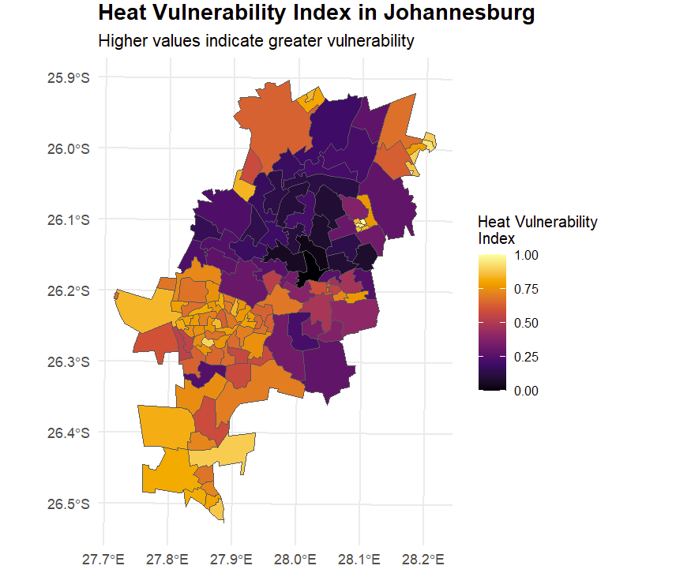

Figure 2: Spatial Distribution of Heat Vulnerability in Johannesburg. (a) Heat Vulnerability Index across all wards, with lighter colours indicating higher vulnerability; (b) Detail of the ten most vulnerable wards, highlighting areas of concentrated risk. Ward boundaries are shown in black, and major roads are in grey.

### Spatial Distribution of Vulnerability

* + - 1. Building on these components, spatial analysis revealed a significant clustering of vulnerability across Johannesburg (Global Moran's I = 0.42, p < 0.001). The LISA analysis identified distinct spatial patterns with statistically significant clusters of both high and low vulnerability (Table 3). High-high clusters, indicating areas of concentrated vulnerability, comprised 28 wards (Mean HVI = 0.78 ± 0.09, Moran's I = 0.68, p < 0.001), while low-low clusters, representing areas of relative resilience, included 35 wards (Mean HVI = 0.23 ± 0.07, Moran's I = -0.55, p < 0.001).

### Characteristics of High-Vulnerability Areas

Within these spatial patterns, five distinct high-vulnerability clusters emerged, each representing unique combinations of environmental, healthcare, and socio-economic challenges (Table 4)(Figure 3). Alexandra Township in the northeast emerged as the most vulnerable area, with extreme environmental exposure (LST: 29.8°C ± 0.4°C) combined with severely limited healthcare access. The Tembisa area showed intense urbanisation impacts, while Tshepisong/Tshepiso demonstrated how infrastructure deficits compound heat vulnerability. Notably, Lenasia South and Soweto clusters showed a different vulnerability pattern - while their LST readings were lower than other clusters (27.8°C and 27.4-29.6°C respectively), their vulnerability was driven by socioeconomic challenges including variable infrastructure quality and limited healthcare facility access, despite having relatively lower rates of public healthcare use and hunger risk compared to other high-vulnerability clusters. This variation in vulnerability drivers highlights the multidimensional nature of heat risk.

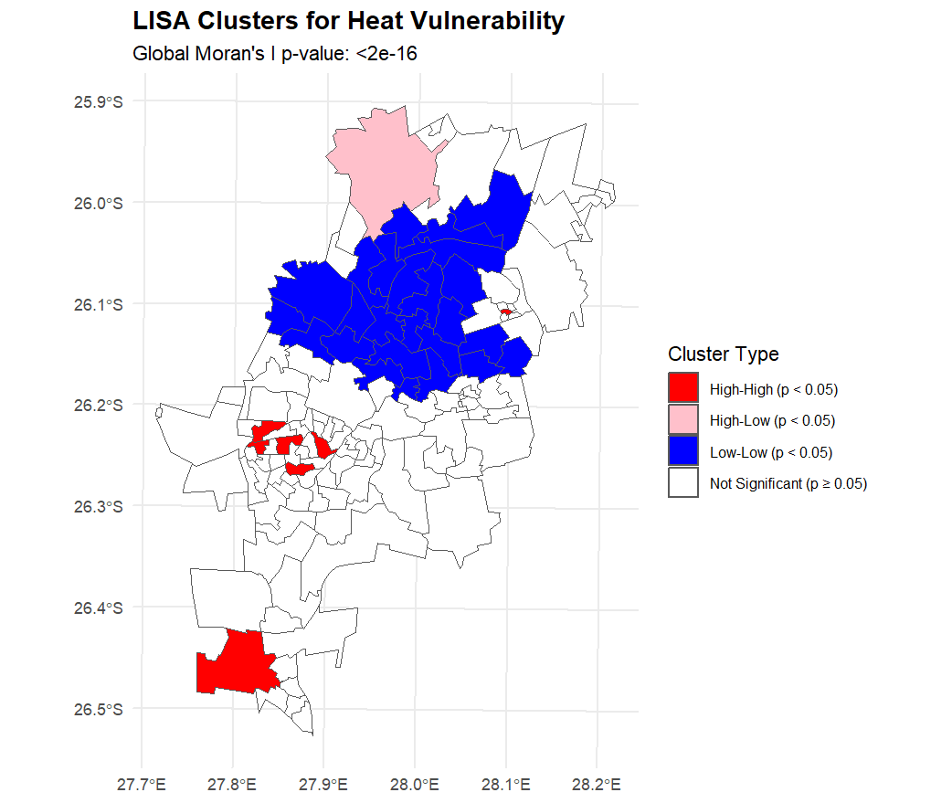

Figure 3: Spatial Clustering of Heat Vulnerability in Johannesburg Based on LISA Analysis. High-high clusters are shown in red, low-low clusters are shown in blue, and spatial outliers are shown in purple. Statistical significance at p < 0.05.

### Environmental-Social Correlations

* + - 1. Examination of Spearman rank correlations revealed several notable associations between socioeconomic indicators and environmental exposures (Table 5). Vegetation cover (NDVI) showed significant negative correlations with household overcrowding (ρ=-0.56, p<0.001) and food insecurity (ρ=-0.58, p<0.001), suggesting a potential protective effect of green space. Conversely, land surface temperature (LST) was positively correlated with crowding (ρ=0.29, p<0.01), lack of health insurance (ρ=0.30, p<0.01), and pneumonia prevalence (ρ=0.26, p<0.01), indicating a convergence of heat exposure and social vulnerability.
      2. Thermal field variance (UTFVI), a measure of extreme heat exposure, was negatively associated with participation in school feeding programs (ρ=-0.33, p<0.001). This suggests that areas facing higher heat stress may have unmet nutritional support needs. Strong intercorrelations were also observed among chronic health conditions, with pairwise Spearman coefficients ranging from 0.54 to 0.75 (p<0.001) for diabetes, hypertension, and heart disease*.*

## Discussion

* + - 1. Our findings reveal how urban heat vulnerability in Johannesburg manifests through a complex interplay of environmental exposure, socio-economic conditions, and healthcare access. The stark spatial patterns we observed suggest that heat vulnerability is not merely a product of environmental factors but is deeply entwined with the city's historical development and ongoing socio-economic disparities.
      2. The emergence of five distinct vulnerability clusters, each with its unique combination of risk factors, challenges conventional approaches to heat adaptation in Global South cities. In Alexandra Township, for instance, we found that extreme environmental exposure (LST: 29.8°C ± 0.4°C) coincides with severely limited healthcare access, with nearly 90% of residents dependent on distant public facilities. This coupling of environmental and social vulnerability creates a compound risk that exceeds what either factor would suggest in isolation. Similar patterns emerge in Tembisa and Tshepisong, where limited infrastructure and high population density amplify the effects of elevated surface temperatures.
      3. Perhaps most striking is how these vulnerability patterns align with Johannesburg's historical spatial segregation. The strong statistical clustering we observed (Global Moran's I p-value: <2e-16) reveals that heat vulnerability follows clear socio-spatial lines, with historically disadvantaged areas showing significantly higher risk profiles. This finding extends previous work on environmental justice in South African cities by quantifying how historical planning decisions continue to shape contemporary environmental health risks[31].
      4. The clear north-south divide in vulnerability patterns raises important questions about urban development and adaptation capacity. While northern suburbs benefit from abundant vegetation and robust healthcare infrastructure, creating significant low-vulnerability clusters, southern regions face compounded challenges. This disparity suggests that conventional approaches to heat adaptation, which often focus solely on environmental interventions like urban greening, may be insufficient without parallel investments in social infrastructure and healthcare access.
      5. Our identification of spatial outliers - particularly high-vulnerability pockets within generally resilient areas - highlights the dynamic nature of urban heat risk. These anomalies often represent informal settlements or areas of rapid urban transformation, suggesting that vulnerability patterns are not static but evolve with urban development. This finding has important implications for adaptation planning, indicating the need for flexible, responsive interventions that can address emerging vulnerability hotspots.
      6. The strong correlation between land surface temperature and socioeconomic indicators revealed in our PCA suggests that environmental and social vulnerabilities are closely linked. Our analysis of environmental and social factors suggests complex interactions in determining heat vulnerability. While environmental exposure plays a significant role (explaining 31.5% of variance in our PCA), the incorporation of socio-economic factors and healthcare access reveals important variations in vulnerability even within areas experiencing similar levels of environmental stress. This interaction between physical and social factors challenges simplistic approaches to urban heat adaptation and suggests the need for integrated interventions that address both environmental and social vulnerability dimensions.[32].
      7. These findings have significant implications for urban policy and planning. While targeted interventions in high-vulnerability clusters are needed, our results suggest that such interventions must simultaneously address multiple dimensions of vulnerability. Simple environmental modifications, while important, may only be sufficient with corresponding improvements in healthcare access and social infrastructure. The clear spatial patterns we observed provide a strong empirical basis for prioritising interventions while identifying compound risk factors, suggesting the need for integrated adaptation strategies.
      8. Our study also reveals several important areas for future research. The strong spatial clustering we observed suggests the need for a more detailed investigation of neighbourhood-level adaptation mechanisms, particularly in high-vulnerability areas. Additionally, identifying spatial outliers raises questions about the dynamics of vulnerability development and the potential for preventive interventions. Future work might also explore how these vulnerability patterns might shift under different climate change scenarios.
      9. These findings advance our understanding of urban heat vulnerability in several essential ways. First, they provide empirical evidence for the spatial clustering of heat risk in a major Global South city. Second, they demonstrate how historical planning decisions shape contemporary environmental health risks. Finally, they reveal the complex interactions between environmental exposure and social vulnerability that must be addressed in urban adaptation planning. As cities worldwide grapple with increasing heat stress under climate change, these insights offer valuable lessons for developing more equitable and effective adaptation strategies.

### Limitations

* + - 1. Although the GCRO Quality of Life Survey provides a rich dataset for exploring urban vulnerabilities, it has some constraints. The survey is not primarily designed as a health assessment, so the derived health metrics should be interpreted as general indicators rather than precise prevalence estimates. Additionally, the self-reported nature of the data may introduce biases, particularly for sensitive health topics.
      2. Second, our focus on Johannesburg offers a detailed case study but may limit the generalizability of the findings to other urban contexts. Cities vary in their specific environmental challenges, socioeconomic conditions, and governance structures, so the patterns observed here may not be universally applicable. Comparative studies across multiple cities would help assess the transferability of our vulnerability assessment approach and identify common themes and context-specific differences.Finally, while we examined a broad set of vulnerability indicators, additional factors that influence heat risk are likely not captured in our analysis. For example, we did not have access to high-resolution data on housing quality, social capital, or behavioural adaptations, which could all shape resilience to heat stress. Integrating a wider range of data sources and vulnerability proxies could provide an even more comprehensive picture.
      3. Despite these limitations, our study demonstrates the value of integrating environmental, socioeconomic, and health data to map urban vulnerability. Identifying key correlations and spatial patterns highlights potential intervention points and future research directions to enhance urban resilience. As cities grapple with the challenges posed by climate change, such interdisciplinary vulnerability assessments will be crucial for guiding equitable adaptation efforts.

## Conclusions

* + - 1. This study provides a comprehensive spatial analysis of heat vulnerability in Johannesburg, revealing how environmental exposure and social inequality create distinct geographic risk patterns. Integrating multiple data streams and advanced spatial statistics, we identified five major vulnerability clusters where environmental hazards and social disadvantage combine to create acute heat risk (Global Moran's I p-value: <2e-16). These patterns demonstrate how historical planning decisions shape contemporary environmental health challenges in South African cities.
      2. Our findings challenge simplistic approaches to urban heat adaptation. While environmental factors account for the largest variance (31.5%), health access and socio-economic conditions play crucial mediating roles. In identified hotspots like Alexandra Township and Tembisa, extreme surface temperatures combined with severely limited healthcare access create a compound vulnerability that neither factor would predict. The spatial precision of our analysis, examining 135 wards across Johannesburg, provides actionable intelligence for urban planning and public health interventions.
      3. As cities worldwide confront increasing heat stress due to climate change, our findings suggest that effective adaptation requires simultaneously addressing environmental exposure and social vulnerability. Future research should examine how these vulnerability patterns evolve and evaluate intervention effectiveness. Most crucially, our results indicate that climate change may exacerbate existing urban inequalities without concerted efforts to address both environmental and social dimensions of heat vulnerability.

## Tables

Table 1. Summary of Environmental, Socioeconomic, and Health Indicators Across Johannesburg Wards (N=135)

|  |  |  |  |  |  |  |
| --- | --- | --- | --- | --- | --- | --- |
| Environmental Indicators | Mean ± SD | Min | 25% | Median | 75% | Max |
| Land Surface Temperature (°C) | 27.92 ± 1.33 | 23.99 | 27.01 | 27.93 | 28.86 | 30.66 |
| UTFVI | -0.06 ± 0.04 | -0.18 | -0.08 | -0.06 | -0.03 | 0.02 |
| NDVI | 0.14 ± 0.04 | 0.04 | 0.11 | 0.14 | 0.17 | 0.21 |
| NDBI | 0.35 ± 0.03 | 0.34 | 0.36 | 0.37 | 0.42 | 0.43 |
|  |  |  |  |  |  |  |
| Socioeconomic Indicators | Mean ± SD | Min | 25% | Median | 75% | Max |
| Crowded Dwellings (%) | 15.19 ± 11.97 | 0.00 | 9.49 | 15.01 | 23.73 | 84.62 |
| Without Piped Water (%) | 5.45 ± 9.45 | 0.00 | 0.00 | 1.89 | 5.67 | 62.95 |
| Using Public Healthcare (%) | 63.47 ± 30.49 | 3.56 | 31.75 | 73.69 | 87.80 | 98.55 |
| Without Medical Insurance (%) | 63.47 ± 26.44 | 7.07 | 38.85 | 73.59 | 84.62 | 97.11 |
| At Risk of Hunger (%) | 32.84 ± 21.91 | 0.00 | 9.49 | 36.78 | 49.73 | 70.01 |
| School Feeding Schemes (%) | 31.33 ± 21.32 | 0.00 | 10.49 | 33.72 | 49.32 | 79.63 |
|  |  |  |  |  |  |  |
| Health Indicators | Mean ± SD | Min | 25% | Median | 75% | Max |
| Poor Health (%) | 7.18 ± 4.48 | 0.00 | 3.97 | 6.09 | 9.95 | 19.98 |
| Unable to Access Healthcare (%) | 4.20 ± 3.67 | 0.00 | 1.50 | 3.83 | 5.58 | 16.97 |
| Diabetes (%) | 11.00 ± 5.00 | 0.00 | 7.00 | 11.00 | 15.00 | 35.00 |
| Heart Disease (%) | 5.00 ± 4.00 | 0.00 | 2.00 | 4.00 | 7.00 | 27.00 |
| Hypertension (%) | 23.00 ± 11.00 | 0.00 | 15.00 | 23.00 | 31.00 | 47.00 |
| HIV (%) | 8.00 ± 7.00 | 0.00 | 3.00 | 7.00 | 12.00 | 27.00 |
| TB (%) | 3.00 ± 4.00 | 0.00 | 0.00 | 2.00 | 5.00 | 12.00 |
| COVID-19 (%) | 4.00 ± 4.00 | 0.00 | 1.00 | 3.00 | 6.00 | 22.00 |

* + - 1. Note: UTFVI = Urban Thermal Field Variance Index; NDVI = Normalized Difference Vegetation Index; NDBI = Normalized Difference Built-up Index. Values represent mean ± standard deviation or percentage where applicable.
      2. For Using Public Healthcare (%), standard deviation reflects the high variability between wards (30.49%) due to clustered access patterns. Twenty-five percent (25%) and seventy-five percent (75%) percentiles are shown as 25% and 75% respectively

Table 2. Principal Component Analysis Results for Heat Vulnerability Indicators

|  |  |  |  |  |
| --- | --- | --- | --- | --- |
| Component | Eigenvalue | Variance Explained (%) | Cumulative Variance (%) | Key Contributing Variables (Loading > 0.3) |
| PC1 (Urban Heat Exposure) | 4.73 | 31.5 | 31.5 | UTFVI (0.35), LST (0.34), NDBI (0.32), NDVI (-0.31) |
| PC2 (Health Status) | 1.92 | 12.8 | 44.3 | Chronic Diseases (-0.32), COVID-19 (-0.30), Healthcare Use (-0.22) |
| PC3 (Socio-economic) | 1.85 | 12.3 | 56.6 | Crowded Dwellings (-0.30), Household Hunger (-0.28) |

Note: Only loadings > |0.2| shown. Kaiser-Meyer-Olkin (KMO) measure = 0.82, Bartlett's test p < 0.001. PC = Principal Component

Table 3. LISA Cluster Analysis Summary

|  |  |  |  |  |  |
| --- | --- | --- | --- | --- | --- |
| Cluster Type | N (Wards) | Mean HVI | Moran's I | p-value | Key Characteristics |
| High-High | 28 | 0.78 ± 0.09 | 0.68 | <0.001 | LST > 29°C, Limited Healthcare |
| Low-Low | 35 | 0.23 ± 0.07 | -0.55 | <0.001 | High Vegetation, Good Healthcare |
| High-Low | 12 | 0.65 ± 0.11 | 0.32 | <0.05 | Informal Settlements |
| Low-High | 8 | 0.35 ± 0.08 | -0.28 | <0.05 | Green Space Islands |

Note: HVI = Heat Vulnerability Index (0-1 scale), ± indicates standard deviation. All spatial statistics calculated using queen contiguity weights matrix.

Table 4. Characteristics of High-Vulnerability Areas

|  |  |  |  |  |
| --- | --- | --- | --- | --- |
| **Region** | **Environmental Indicators** | **Healthcare Access** | **Socio-Economic Factors** | **Health Indicators** |
| Alexandra Township | LST: 29.8°C ± 0.4°C; NDVI: 0.08 ± 0.02 | Public healthcare use: 89.2%; Avg distance to facilities: >3km | Household hunger risk: 70.0%; Crowded dwellings: 37.5% | Hypertension rate: 1.5× avg; Chronic disease burden: High |
| Tembisa Areas | LST: 28.9°C ± 0.5°C; NDVI: 0.13 ± 0.03 | Public healthcare use: 78.5%; Avg distance to facilities: 2.8km | Household hunger risk: 56.4%; Crowded dwellings: 32.5% | COVID-19 rates: Above avg; TB prevalence: High |
| Tshepisong/Tshepiso | LST: 29.2°C ± 0.3°C; NDVI: 0.11 ± 0.03 | Public healthcare use: 67.8%; Avg distance to facilities: 3.1km | Household hunger risk: 58.4%; No piped water: 45.2% | Infectious disease: High; Healthcare access: Limited |
| Lenasia South | LST: 27.8°C ± 0.6°C; NDVI: 0.14-0.22 | Public healthcare use: 64.5%; Avg distance to facilities: 2.5km | Household hunger risk: 52.3%; Crowded dwellings: 26.8% | Chronic disease: High; Healthcare access: Limited |
| Soweto Clusters | LST: 27.4-29.6°C; NDVI: 0.09-0.16 | Public healthcare use: 75.8%; Avg distance to facilities: 2.9km | Household hunger risk: 48.2%; Crowded dwellings: 28.4% | Chronic disease: Above avg; Healthcare access: Variable |

Note: LST = Land Surface Temperature; NDVI = Normalized Difference Vegetation Index. All metrics shown with standard deviations where applicable.

**Table 5: Correlation Matrix of Key Variables (Spearman's ρ)**

|  |  |  |  |  |
| --- | --- | --- | --- | --- |
| **Variable** | **LST** | **NDVI** | **Healthcare Access** | **Poverty Index** |
| LST | 1*** | -0.29*** | 0.28** | 0.41*** |
| NDVI | -0.29*** | 1*** | -0.65*** | -0.56*** |
| Healthcare Access | 0.28** | -0.65*** | 1*** | 0.83*** |
| Poverty Index | 0.41*** | -0.56*** | 0.83*** | 1*** |

Note: *** p < 0.001, ** p < 0.01, * p < 0.05. N = 135 wards. LST = Land Surface Temperature; NDVI = Normalized Difference Vegetation Index.

## References

1. Intergovernmental Panel on Climate, C., *Climate Change 2022: Impacts, Adaptation and Vulnerability. Contribution of Working Group II to the Sixth Assessment Report of the Intergovernmental Panel on Climate Change*. 2022, Cambridge University Press.

2. Ansah, E.W., et al., *Climate change, urban vulnerabilities and adaptation in Africa: a scoping review.* Climatic Change, 2024. **177**(4): p. 71.

3. Estoque, R.C.O.M.A.V.H.Y.D.R.T.T.M.Y.N.S., *The future of Southeast Asia’s forests.* Nature Communications, 2023. **10**(1): p. 1829-1829.

4. Tuholske, C.C.K.F.C.V.A.S.S.G.K.P.P.E.T., *Global urban population exposure to extreme heat.* Proceedings of the National Academy of Sciences, 2021. **118**(41): p. e2024792118-e2024792118.

5. Tietjen, B., K. Jacobsen, and J. Hollander, *Climate Change and Urban Migration in Sub-Saharan African Cities: Impacts and Governance Challenges.* Journal of Climate Resilience and Justice, 2023. **1**: p. 20-32.

6. Abrahams, D.E.D., *City Scoping Study: Johannesburg.* African Centre for Cities, 2019.

7. Souverijns, N., K. De Ridder, and N. Veldeman, *Urban heat in Johannesburg and Ekurhuleni, South Africa: A meter-scale assessment and vulnerability analysis.* Urban Climate, 2022. **46**: p. 101331.

8. Giombini, V. and J.P.R. Thorn, *Urban Green Spaces in a Post-Apartheid City: Challenges and Opportunities for Nature-based Solutions*, in *Human-Nature Interactions: Exploring Nature’s Values Across Landscapes*, I. Misiune, D. Depellegrin, and L. Egarter Vigl, Editors. 2022, Springer International Publishing: Cham. p. 207-219.

9. Statistics South, A., *Urban Development Report 2023.* Statistics South Africa, 2023.

10. Schlosberg, D.R.L.B.J., *Environmental justice and attachment to place: Australian cases.* Environmental Politics, 2022. **31**(1): p. 1-20.

11. Wang, Y.U.B.R., *Urban resilience to climate change: A systematic literature review.* Sustainable Cities and Society, 2023. **85**: p. 104080-104080.

12. Li, X., et al., *The surface urban heat island response to urban expansion: A panel analysis for the conterminous United States.* Science of The Total Environment, 2017. **605-606**: p. 426-435.

13. Oke, T.R., *The energetic basis of the urban heat island.* Quarterly journal of the royal meteorological society, 1982. **108**(455): p. 1-24.

14. Santamouris, M., *Analyzing the heat island magnitude and characteristics in one hundred Asian and Australian cities and regions.* Science of The Total Environment, 2015. **512-513**: p. 582-598.

15. Voogt, J.A. and T.R. Oke, *Thermal remote sensing of urban climates.* Remote sensing of environment, 2003. **86**(3): p. 370-384.

16. Zhou, D., et al., *Surface urban heat island in China's 32 major cities: Spatial patterns and drivers.* Remote Sensing of Environment, 2014. **152**: p. 51-61.

17. Watts, N.A.M.A.N. and et al., *The 2023 report of the Lancet Countdown on health and climate change: health at the mercy of fossil fuels.* The Lancet, 2023. **402**(10397): p. 1610-1654.

18. Khosla, R., A. Jani, and R. Perera, *Health risks of extreme heat.* BMJ, 2021. **375**: p. n2438.

19. Desai, Y., H. Khraishah, and B. Alahmad, *Heat and the Heart.* Yale J Biol Med, 2023. **96**(2): p. 197-203.

20. Urban Heat Study, G., *Urban Heat Islands in South African Cities: A Comprehensive Analysis.* South African Environmental Observation Network, 2023.

21. World Health, O., *Global Report on Urban Health: Equitable, Healthier Cities for Sustainable Development.* World Health Organization, 2023.

22. Ansah, E.W., et al., *Health systems response to climate change adaptation: a scoping review of global evidence.* BMC Public Health, 2024. **24**(1): p. 2015.

23. Souverijns, N., et al., *Urban heat in Johannesburg and Ekurhuleni, South Africa: A meter-scale assessment and vulnerability analysis.* Urban Climate, 2022. **46**: p. 101331.

24. United States Geological, S., *Landsat 8 Satellite Imagery (December-February 2020-2021)*. 2021.

25. Google Earth, E. and I. Landsat 8 Satellite, *Environmental Indices for Johannesburg: LST, NDVI, and NDBI Calculated in Google Earth Engine*. 2021.

26. Observatory, G.C.-R., *Quality of Life Survey 6 (2020/21): Overview Report*. 2021, Gauteng City-Region Observatory.

27. Observatory, G.C.-R., *Quality of Life Survey 6 (2020/21) Questionnaire*. 2022, Gauteng City-Region Observatory.

28. Harris, P., C. Brunsdon, and M. Charlton, *Geographically weighted principal components analysis.* International Journal of Geographical Information Science, 2011. **25**: p. 1717-1736.

29. Qureshi, A.M. and A. Rachid, *Heat Vulnerability Index Mapping: A Case Study of a Medium-Sized City (Amiens).* Climate, 2022. **10**(8): p. 113.

30. Anselin, L., *Local Indicators of Spatial Association—LISA.* Geographical Analysis, 1995. **27**(2): p. 93-115.

31. Strauss, M., *A historical exposition of spatial injustice and segregated urban settlement in South Africa.* Fundamina, 2019. **25**(2): p. 135-168.

32. Wright, C.Y., et al., *Socio-economic, infrastructural and health-related risk factors associated with adverse heat-health effects reportedly experienced during hot weather in South Africa.* Pan African medical journal, 2019. **34**(1).

## Supplementary materials

**Table 6(Supplementary): Comparative Rankings of Combined Heat Vulnerability Index (HVI) and Component Factors**

|  |  |  |  |  |  |  |  |  |  |  |  |  |  |  |
| --- | --- | --- | --- | --- | --- | --- | --- | --- | --- | --- | --- | --- | --- | --- |
| **Rank** | **Combined HVI Ward** | **Combined HVI Value** | **Heat Exposure Ward** | **Heat Exposure Value** | **Low Vegetation Ward** | **Low Vegetation Value** | **Public HC Ward** | **Public HC Value** | **No Insurance Ward** | **No Insurance Value** | **Hunger Risk Ward** | **Hunger Risk Value** | **Crowded Ward** | **Crowded Value** |
| 0 | Ward 87 | 1 | Ward 116 | 30,66 | Ward 63 | 0,045 | Ward 128 | 98,6 | Ward 128 | 97,1 | Ward 2 | 70 | Ward 113 | 51,5 |
| 1 | Ward 117 | 0,97 | Ward 108 | 30,56 | Ward 116 | 0,054 | Ward 35 | 96,5 | Ward 61 | 94,5 | Ward 6 | 69 | Ward 95 | 43,4 |
| 2 | Ward 88 | 0,94 | Ward 113 | 30,37 | Ward 108 | 0,057 | Ward 127 | 95,6 | Ward 116 | 94,2 | Ward 48 | 66,7 | Ward 114 | 40,8 |
| 3 | Ward 72 | 0,92 | Ward 135 | 30,37 | Ward 62 | 0,058 | Ward 21 | 94,8 | Ward 19 | 94,2 | Ward 121 | 64,4 | Ward 37 | 40,5 |
| 4 | Ward 90 | 0,92 | Ward 8 | 30,35 | Ward 133 | 0,065 | Ward 40 | 94,4 | Ward 111 | 92,9 | Ward 130 | 63,7 | Ward 107 | 40 |
| 5 | Ward 73 | 0,91 | Ward 107 | 30,14 | Ward 107 | 0,068 | Ward 24 | 93,5 | Ward 6 | 91,6 | Ward 15 | 63,2 | Ward 2 | 37,5 |
| 6 | Ward 103 | 0,9 | Ward 96 | 30,09 | Ward 77 | 0,075 | Ward 130 | 93,3 | Ward 75 | 91,6 | Ward 45 | 61,5 | Ward 75 | 37,2 |
| 7 | Ward 104 | 0,89 | Ward 32 | 30,06 | Ward 79 | 0,076 | Ward 50 | 93,3 | Ward 53 | 91,2 | Ward 47 | 61,3 | Ward 116 | 36 |
| 8 | Ward 99 | 0,88 | Ward 105 | 29,98 | Ward 76 | 0,076 | Ward 34 | 92,2 | Ward 59 | 91 | Ward 51 | 60,2 | Ward 35 | 35,7 |
| 9 | Ward 106 | 0,87 | Ward 76 | 29,88 | Ward 75 | 0,078 | Ward 11 | 92,1 | Ward 127 | 90,8 | Ward 41 | 60,1 | Ward 44 | 33,2 |

This table illustrates disparities between the Combined Heat Vulnerability Index (HVI) and its component factors (Heat Exposure, Vegetation, Healthcare Access, and Socio-Economic Conditions). Highlighting these differences underscores the multidimensional nature of heat vulnerability and the need for targeted interventions addressing both individual drivers and their combined impacts.

